Celebrating 21 Years of the Walled Kitchen Gardens Network

Retrospective & Renaissance - revival of the Walled Kitchen Garden

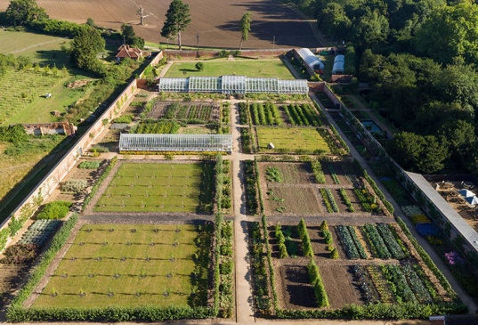
The Forum will take place on:
Friday 14th Oct. Audley End 10:00am – 5:00pm registration from 9:00am

Saturday 15th Oct. visits to other walled kitchen gardens 10:00 – 4:00

Times may be subject to slight change

Tickets for both days: £150 - Friday only: £85, Saturday only: £65

Tickets will include: talks, lunch & refreshments on both days, entry and tours of gardens.
We can offer concessions to full-time students: Saturday £65, Sunday £50.
Tell us where you are studying and the course you are undertaking

Name: …..

Address: ….

Email: ….. Telephone: …..

Organisation/Garden/other: …..

I am/we are members of: National Trust RHS English Heritage

I/we would like to book …… place(s) for the WKGN Forum 2022, Audley End

Both days: yes/no Friday only: yes/no Saturday only: yes/no

Please send online payment to:
Walled Kitchen Gardens Network sort code 20-53-22 acct. no. 80691658

Complete and return form to: lucypitman@virginmedia.com or send to the address below
If you require an invoice, or for payments not online, please contact us

